

IQ Puzzler

**Analysis Report**

***Game Of Objects***

**Zafer Çınar**

**Arda Türkoğlu**

**Engin Deniz Kopan**

**Mehmet Selim Özcan**

**Mehmet Sanisoğlu**

Oct 21, 2018

**Table of Contents**

**1.** Introduction

**2.** Overview 2.1 Gameplay 2.2 Map 2.3 Shapes 2.4 Game Modes 2.4.1 Casual 2.4.2 Time Bomb 2.4.3 Rotating Maps 2.5 Settings

**3.** Functional Requirements 3.1 Play Game 3.2 Game Modes & Levels 3.3 How To Play 3.4 Settings 3.5 Statistic 3.6 Credits

**4.**  Non-Functional Requirements 4.1 Performance 4.2 Usability 4.3 Extendibility 4.4 Supportability

**5.** System Models 5.1 Use-Case Model 5.2 Dynamic Models 5.2.1 Sequence Diagrams 5.2.1.1 Start Game and Select Game Mode 5.2.1.2 Display Credits 5.2.1.3 Display How To Play 5.2.1.4 Display Statistics 5.2.1.5 Display Settings 5.2.2 Activity Diagram 5.3 Class Diagrams 5.4 User Interface-Navigational Path and Mock-ups 5.4.1 Navigational Path 5.4.2 Mock-ups

**6.** References & Glossary

# 1.Introduction:

IQ Puzzler Pro is the ultimate board game for people who enjoy fitting pieces together. You are given a set of solid, pre-defined shapes, made of marble sets of 3 or 4, and asked to place them in the board map. In each board map chosen, you first place the mandatory pieces in the way it is described in the current map settings, which you cannot relocate. Then, by using the leftover pieces, you try to fill the rest of the board with each piece in its correct placement. There is only one possible course of action per map, pushing the player to his limits.

By changing the board face you play, you are allowed to change the game mode. With an isometric surface on the back-side board, player is faced with new challenges to overcome and conquer. Also, with the 3D game mode, pieces are placed on top of each other, with aim to form a perfect pyramid, while pushing you to change your perspective.

As it can be seen in here, the game itself is very intuitive to construct with the object-oriented design. With the help of Java FX we aim to deliver a solid, easy to grasp and fun to play game with adequate visual quality.

# 2.Overview:

Our project is going to be a 2D to 3D implementation of IQ Puzzler Pro in Windows OS with additions to the base project with new features that enable a multiplayer game mode as well as new playstyles like time bomb and rotating map that make the play more difficult.

2.1 Gameplay

IQ Puzzler Pro is a single player game, with potential to be multiplayer, with both 2D and 3D play styles. The player chooses the map to play and faced with the problem, where the non-moving shapes are different each time and forces the player to ponder unique way to place his given pieces. By dragging and rotating the given shapes the map is slowly filled to the point of no empty spaces, in which case every shape must have been placed correctly.

**2.2 Map**

The map will have a constant background colour or theme, that will have different scenarios in them in each different map. The maps each, with its pre-defined solid shapes, enable a different playthrough for the player.

2.3 Shapes

Shapes will be located in the container next to map. They will have a shape of one of the pre-determined shapes like “Z”, “L” and etc. They will be able to rotate and change the direction they face to fit the right place. Each piece will have a colour for the ease of differentiating them from each other.

2.4 Game Modes

There will be 2 main game modes, Single player and Multiplayer. In multiplayer you try to beat your opponent with your score, which you get based on the number of moves you do and the time it takes for you to complete the level. In single player you can choose one of the game modes of “Casual”, “Time Bomb” or “Rotating Map”.

2.4.1 Casual

In this mode player is given the basic game, with no time-limits or any other constraining factors. The sole purpose is to finish the level, casually. There is no score being tracked.

2.4.2 Time Bomb

Time Bomb game mode forces the player to think fast and act faster. Player has to find the right combination of shape placements and finish the level before the time bomb, with a pre-defined given time, goes off. Each move the player does is counted and will reduce the score he gets in the end.

2.4.3 Rotating Map

In this game mode, map is rotated every once in a while, in either clockwise or counter-clockwise direction. The direction of the rotation is random. The player not only has to work it out and find the correct placements, but also has to be quick enough the place the shape in its right place before the map rotates. The player’s score is based on the number of moves he does.

2.5 Settings

The player has the choice to adjust the volume of the game music and the clicking sounds. Also, player can change the colour of the shapes, background, time limit and screen mode.

**3. Functional Requirements**

**3.1 Play Game**

In Main Menu there will be several buttons and first one is “play game” button. By pressing this button, players will be able to start game. The map will be constructed according to players’ choices of game modes and levels (Check 3.2). Right side of each map (if the game is multiplayer there will be 2 maps) there will be remain shapes that players will try to put them into the map by using mouse for filling the map and completing levels. At the top side there will be time and move count. When players finish the game there will be a pop-up screen to show them their time and move score. Also, there will be 2 buttons on that screen: Next Level and Menu.

**3.2 Game Modes & Levels**

Players can access this screen from Main Menu also. First players will decide their game dimension: 2D or 3D. After that, as we explained at ***2.4*** there are two main game modes: Single and Multiplayer. If players select the multiplayer mode there will be two identical maps with same selected level in the game and opponents will try to finish first. In and Rotating Map (check 2.4).

Players can also select different levels. There are 20 levels and each level is harder than previous one. Players must unlock the next level by finishing the current level. After unlocking levels players can choose any level with any game mode.

**3.3 How To Play**

Players can access this screen from Main Menu. This screen will have information about general rules of IQ Puzzler and also game modes explanation. This information will help to players to understand the game and play it without any trouble. Players can also access this screen during the game by pressing “P”.

**3.4 Settings**

This screen will be also available at Main Menu. By entering this screen players will be able to change some qualities for their choices.

Players can also access this screen by pressing “O” during the game. Settings:

* Adjustment of volume
* Colour of background
* Colour of shapes
* Time limit
* Fullscreen/Windowed

**3.5 Statistics**

Players can access their statistics from Main Menu. There are several kinds of statistics that game will be recording during the match. Information are:

* Total time spent
* Average time spent per game
* Total move count
* Average move count per game
* Count of plays of each game mode
* Best time for each level
* Less move count for each level

This information will make our game more competitive and more addictive for players. Players can also access this screen by pressing “S”.

**3.6 Credits**

In this screen information related to the developers of the game(Game of Objects) is located. There will be our e-mails in this screen in order to provide our users to send their feedback and suggestions.

**4. Non-Functional Requirements**

**4.1 Performance**

In order to make our game working in good performance we are planning to create our shapes, Maps, and Interface with high quality and also we will be adding extra animations to our shapes’ movement and Map’s rotation (in rotating map game mode). We will be focusing to implement our game with real-life response time and as high FPS (frame per second) as we can do. Also, system requirements of our game will be as low as possible with less need of empty space because we want our game to be playable almost every computer.

**4.2 Usability**

Since original IQ Puzzler game can be played by everyone above 6 years old, our game will be also very easy to use. We will also provide “How to play” screen to our users in order to explain our game modes which are extra from original game. Our Interface will be user-friendly and very easy to understand what to do. We will provide our users to guideline to play the game when they first open the game. As we explained above, players can also access different helpful screens during the gameplay by pressing the designated buttons.

**4.3 Extendibility**

We are already planning to extend our game from original IQ Puzzler board game. We have added multiplayer choice and three different game modes. Our game is very easy to extend because IQ Puzzler’s main goal is improvement of players’ way of thinking and their handling the different situations. Therefore, extending this game actually comes up naturally. We are considering these listed changes and improvements for future versions:

* Different kind of maps
* Different kind of shapes
* Combination of 2D and 3D
* More levels
* Making the game online
* …

**4.4 Supportability**

We will try to maintain our game as long as we can. To achieve this militainment we will try to detect and solve every bug. We are already providing a feedback system to our players. By this system users can inform us with the unfixed bugs. Also, feedbacks will provide us to have information of users’ critics and desires. We can adapt ourselves and our game by considering these feedbacks.

**5. System Models**

**5.1 Use-Case Model**

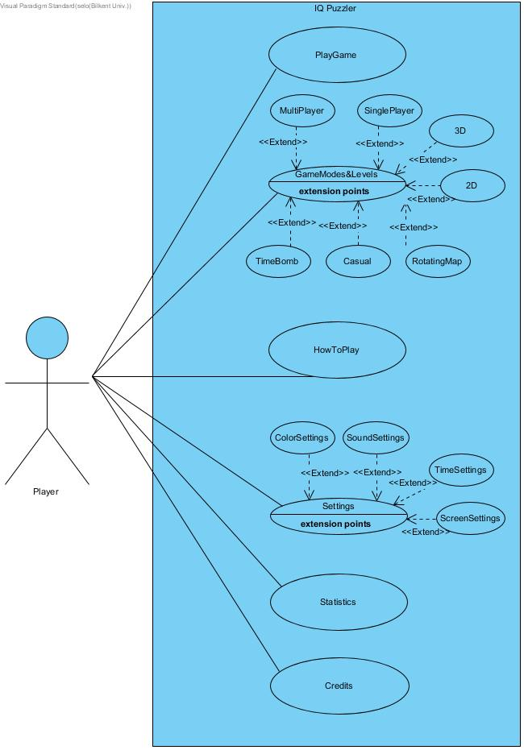

**Use Case #1**

Use Case : Play Game

Primary Actor : Player

Stakeholders and Interests:

* Player/Players want to play the game
* System create the game and starts it

Pre-conditions:

* Player must be in the main menu

Entry conditions:

* Player selects the “Play Game” button from main menu
* Player should have been chosen the game mode

Exit conditions:

* Player successfully finished the game by completing all levels

Success Scenario Event Flow:

1. Player selects “Play Game” button from main menu
2. Player moves shapes by holding mouse left key
3. Player fills the map until no space left
4. Player finished the level and goes to next level
5. Player repeats steps 2 to 5
6. Player finished the Single Player Casual 2D mode. (If there is no pre-designated game mode or dimension)

**Use Case #2**

Use Case : GameMode&Levels

Primary Actor : Player

Stakeholders and Interests:

* Player wants to choose game mode and level
* System goes to GameMode screen
* System constructs the game according to choices of Player

Pre-conditions :

* Player must be in the Main Menu

Entry conditions:

* Player selects “GameModes & Levels” button from main menu screen

Exit conditions:

* Player presses “Back” button

Success Scenario Event Flow:

1. Player selects “GameModes & Levels” button from main menu screen
2. System displays GameMode screen.
3. Player selects dimension : 2D or 3D
4. Player selects number of player : Single or Multi
5. Player selects GameMode : Casual , TimeBomb or RotatingMap (if single player chosen)
6. Player selects the unlocked level
7. Player presses “Back” button
8. System displays Main Menu

**Use Case #3**

Use Case : How To Play

Primary Actor : Player

Stakeholders and Interests:

* Player wants to learn how to play IQ Puzzler
* System goes to HowToPlay screen

Pre-conditions :

* Player must be in the Main Menu or in the game

Entry conditions:

* Player selects “How To Play” button from main menu
* Player presses “P” during the game

Exit conditions:

* Player presses “Back” button
* Player presses “Esc” from keyboard

Success Scenario Event Flow:

1. Player selects “How To Play” button from main menu
2. System displays How To Play screen

Alternative Event Flow:

1. Player presses “P” during the game
2. System displays “How To Play” screen

**Use Case #4**

Use Case : Settings

Primary Actor : Player

Stakeholders and Interests:

* Player wants to adjust the settings
* System goes to Settings screen
* System changes the game settings according to choices of Player

Pre-conditions :

* Player must be in the Main Menu

Entry conditions:

* Player selects “Settings” button from main menu
* Player presses “O” during the game

Exit conditions:

* Player presses “Back” button
* Player presses “Esc” from keyboard

Success Scenario Event Flow:

1. Player selects “Settings” button from main menu
2. System displays Settings screen
3. Player adjusts colour settings
4. Player adjusts time settings
5. Player adjusts sound settings
6. Player adjusts screen settings
7. Player presses “Back” button
8. System changes setting according to Player’s choices

Alternative Event Flow:

1. Player presses “O” during the game
2. System displays “Settings” screen
3. Same steps of Success Scenario Event Flow from 3 to 8.

**Use Case #5**

Use Case : Statistics

Primary Actor : Player

Stakeholders and Interests:

* Player wants learn statistics
* System goes to Statistics screen

Pre-conditions :

* Player must be in the Main Menu or in game

Entry conditions:

* Player selects “Statistics” button from main menu
* Player presses “S” during the game

Exit conditions:

* Player presses “Back” button
* Player presses “Esc” from keyboard

Success Scenario Event Flow:

1. Player selects “Statistics” button from main menu
2. System displays Statistics screen

Alternative Event Flow:

1. Player presses “S” during the game
2. System displays “Statistics” screen

**Use Case #6**

Use Case : Credits

Primary Actor : Player

Stakeholders and Interests:

* Player wants to give feedback
* System goes to Credits screen

Pre-conditions:

* Player must be in the Main Menu

Entry conditions:

* Player selects “Credits” button from main menu

Exit conditions:

* Player presses “Back” button
* Player presses “Esc” from keyboard

Success Scenario Event Flow:

1. Player selects “Credits” button from main menu
2. System displays Credits screen

**5.2 Dynamic Models**

**5.2.1 Sequence Diagrams**

**5.2.1.1 Start Game and Select Game Mode**

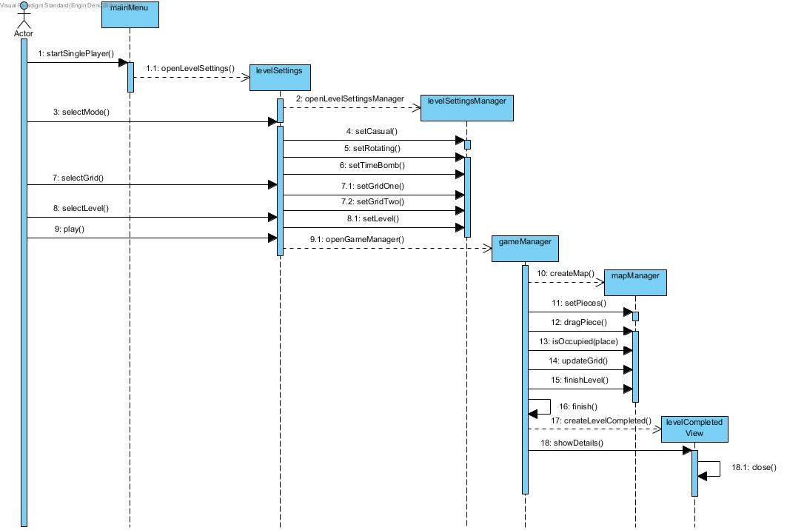

**Scenario**: Starting a new game   
 Player wants to start the game. Player enters the main menu and selects one of the modes; single player or multiplayer. After mode selection, player needs to decide settings of the mode before the game starts. Player should select the following options;

* Mode
* Grid
* Level

After all of those are finished, the game is initialized by the level settings manager. The creation of the grid, the pieces on the screen is identified by the game manager. When the grid and pieces are now placed, according to game mode, player starts to play the game. Player should put the right pieces to the accurate locations so that the level is completed

**5.2.1.2 Display Credits**

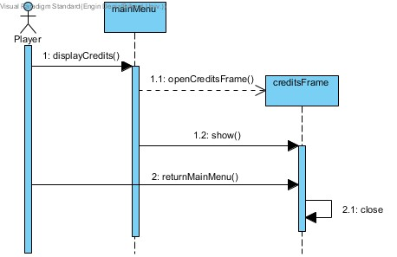

**Scenario:** Player wants to see the credits panel   
  
 When the player clicks the credits button, he or she is going to see a credits panel which consists of some information about the developers of the game.

**5.2.1.3 Display How To Play**

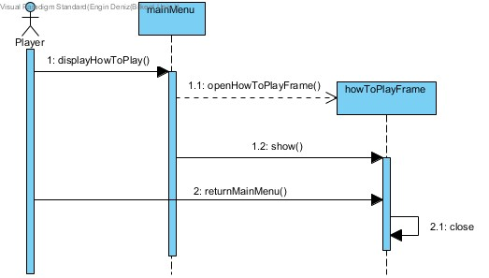

**Scenario:** Player wants to know the rules of the game   
  
 When the player clicks the how to play button, he or she is going to see a panel which consists of information about rules of the game. This panel is as same as the credits panel except their information.

**5.2.1.4 Display Statistics**

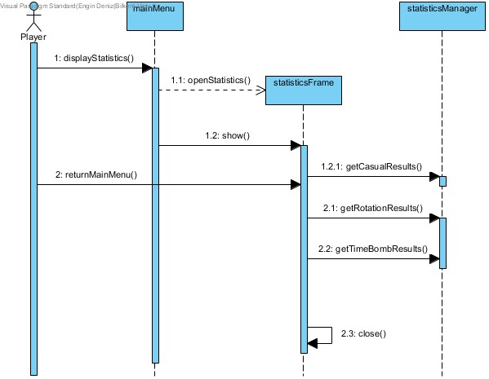

**Scenario:** Player wants to know the statistics of the game   
  
 If the players clicks the statistics button, he or she will be able to see the statistics of the game according to game mode, best time, total time spent and best move count.

**5.2.1.5 Change Settings**

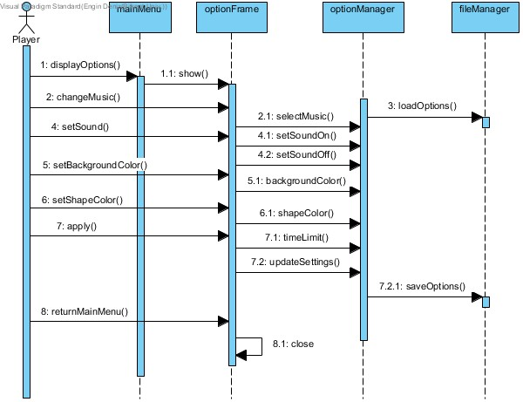

**Scenario**: Player pushes the settings button   
 Player wants to adjust the settings according to preferences. When the player goes to the settings panel, he or she can select the settings as follows;

* Change Music
* Set Sound
* Set Background Colour
* Set Shape Colour
* Set Time Limit

After the player applies those changes, selected settings will be saved and when the player intents to play the game, he or she will begin the game with his or her options.  
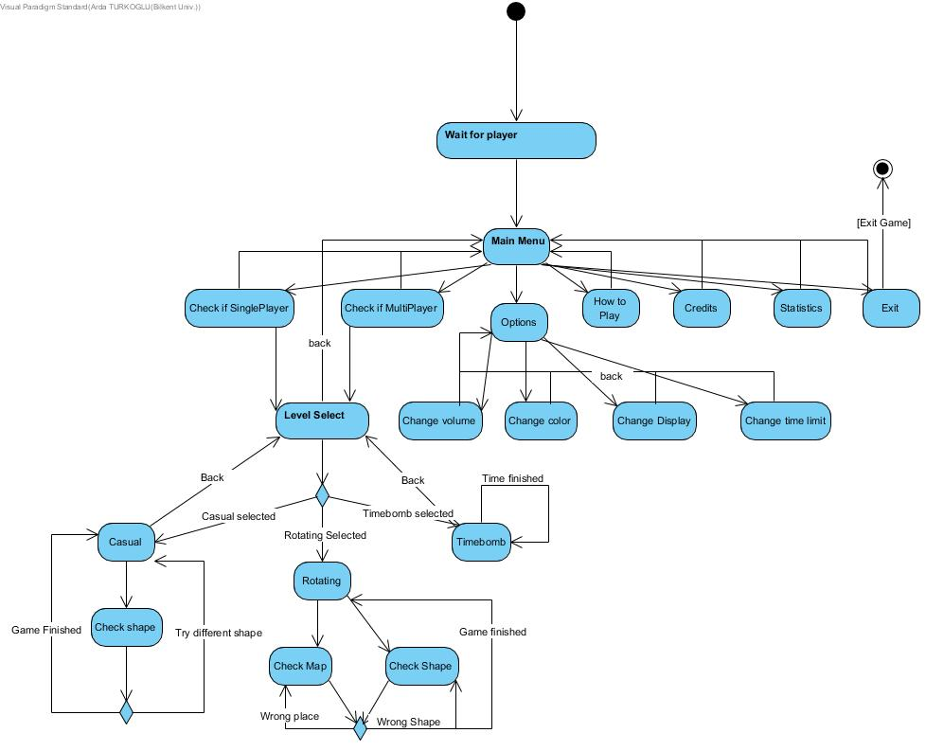 **5.2.2 Activity Diagram**

**5.3 Class Diagram**

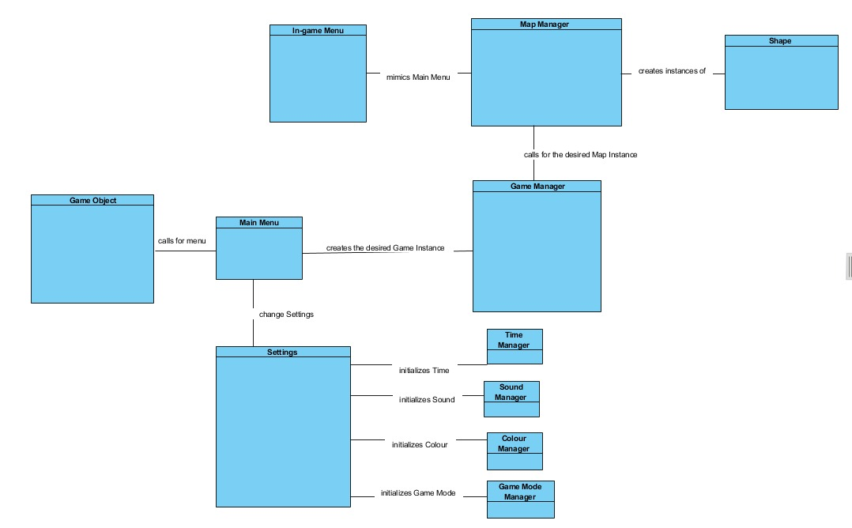

**5.4 User Interface – Navigational Path and Mock-ups**

**5.4.1 Navigational Path**

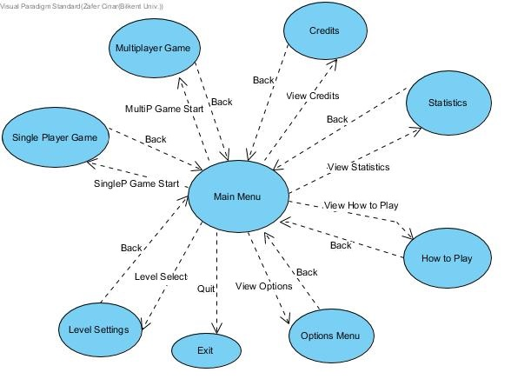

**5.4.2 Mock-ups**

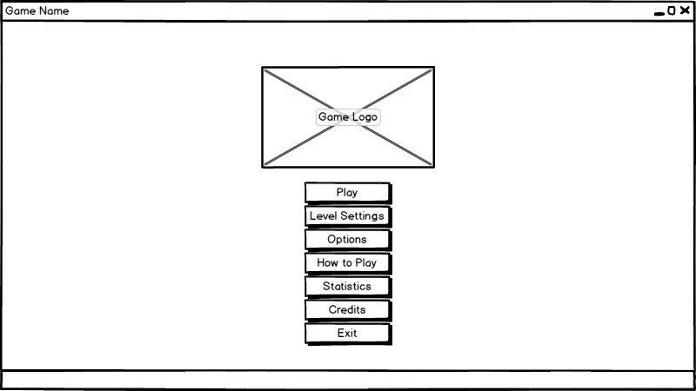

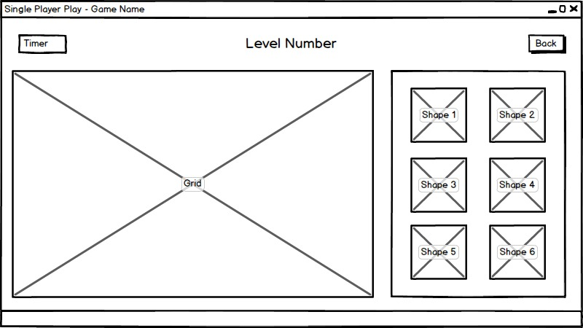

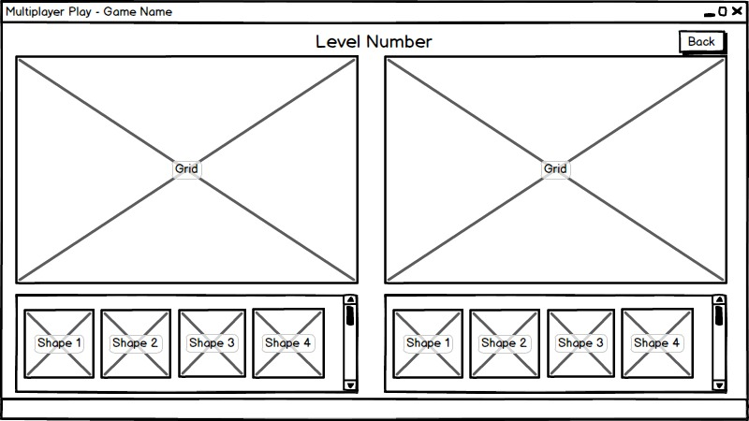

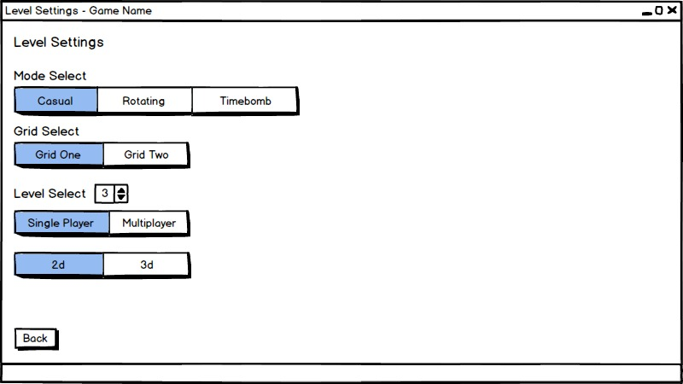

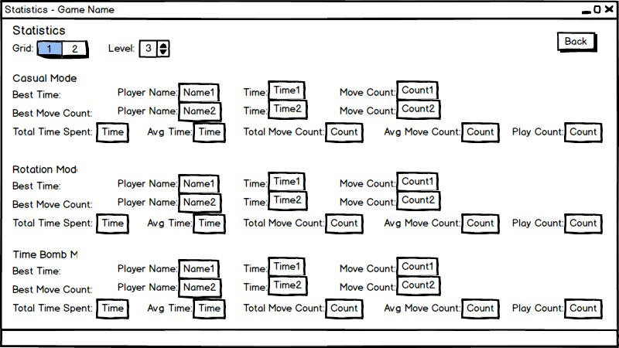

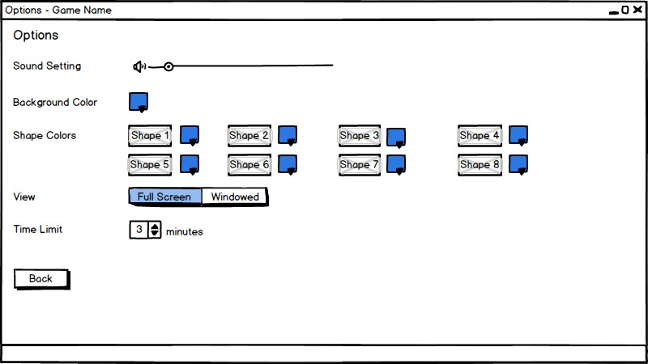

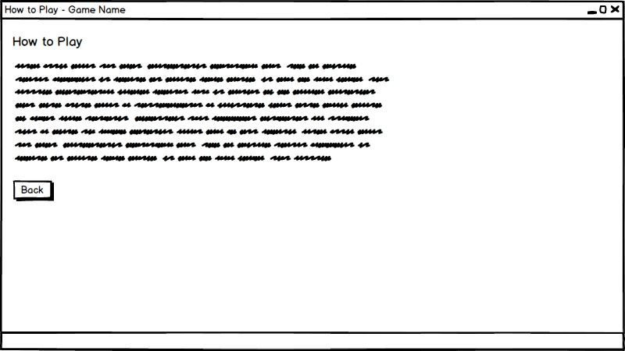

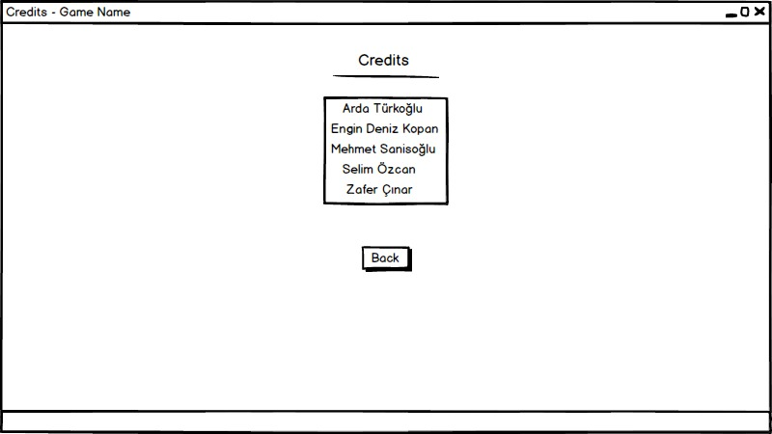

**6. References & Glossary**

*https://www.egitimdizayn.com/iq-puzzler-pro*